CRM Application For Jewel Management

College Name: AVP College Of Arts And Science

College Code: bruaj

Team ID: NM2025TMID25314

Team Members:

Team Leader : Suvalakshmi S

Email: suvalakshmipadma@gmail.com

Team Member1 : Abinaya J

Email:abinayajayapandi@gmail.com

Team Member2: Ratsana S

Email: ratsanasampath@gmail.com

Team Member3: Sweetlin B

Email: sweetlinbasker123@gmail.com

1.INTRODUCTION

**1.1 Overview of CRM Application for Jewel Management**

Customer Relationship Management (CRM) is a strategic approach and accompanying software designed to manage, analyze, and enhance interactions with current and prospective customers. At its core, a CRM centralizes customer data including contact details, communication history, and behavior while providing tools for sales, marketing, and support automation to boost engagement, retention, and business growth.

**1.2 Objectives**

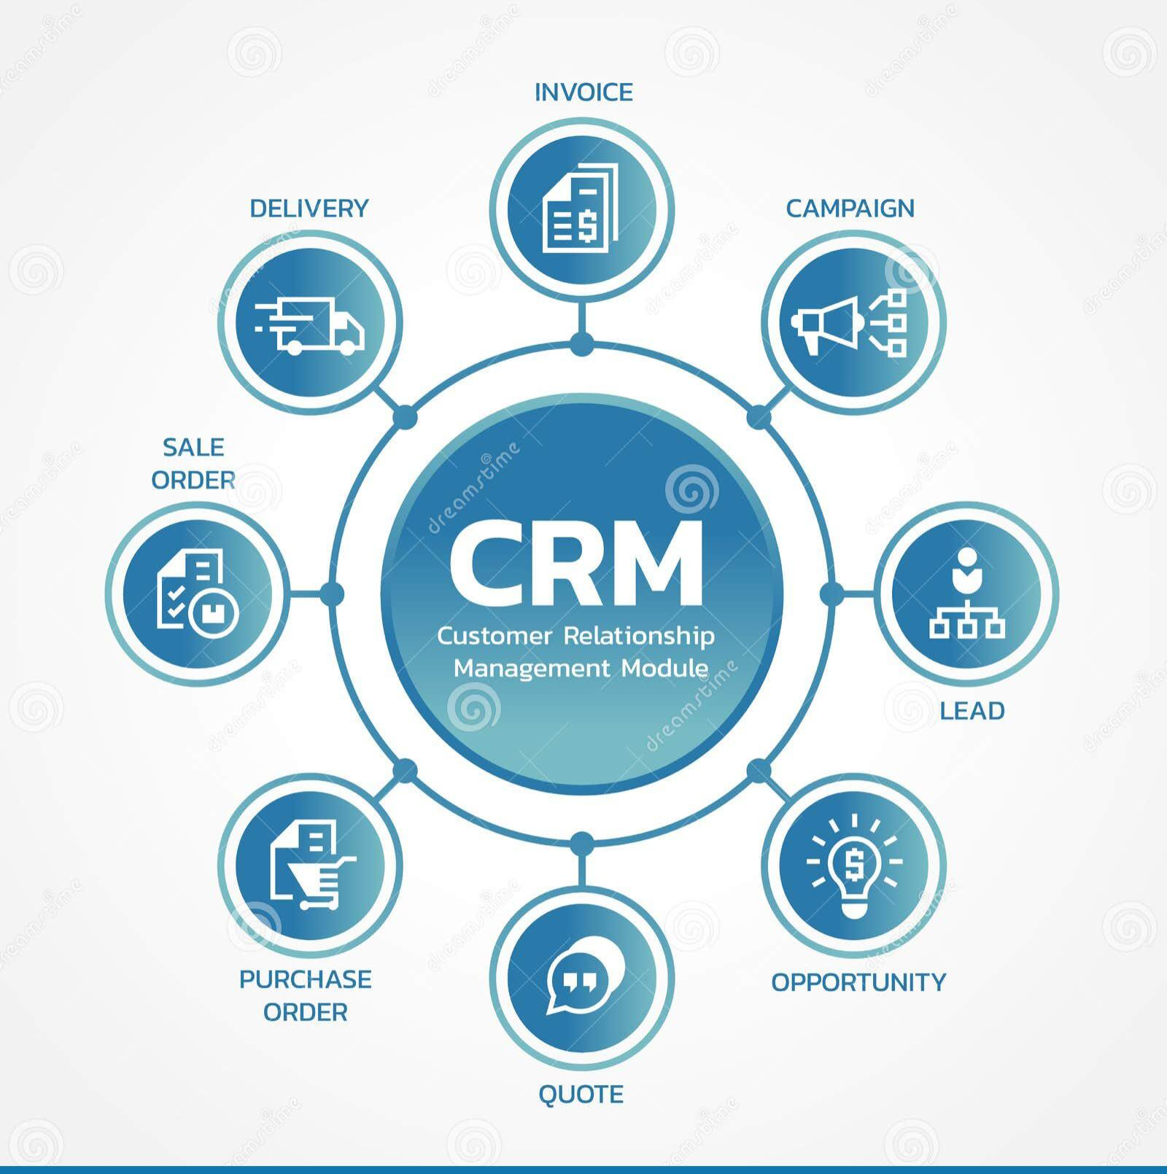 The key goals of implementing a CRM tailored for jewel management revolve around centralizing customer insights, enhancing personalized service, streamlining sales workflows, optimizing inventory tracking, and enabling data‑driven growth. By centralizing customer data preferences, purchase history, and special occasions teams can deliver tailored experiences that foster trust and loyalty. The CRM elevates personalized engagement, allowing targeted campaigns and VIP programs that resonate with high‑value clients and boost repeat purchases. Through automated reminders and sales management, such as follow‑ups for anniversaries or sales pipeline tracking, jewelers minimize manual tasks and ensure no opportunity slips through, directly driving efficiency and sales conversion. Integration with POS and real‑time inventory and order tracking ensures stock accuracy and smooth fulfilment essential when handling high‑value items across multiple locations. Finally, the CRM delivers actionable analytics and reporting, providing visibility on performance metrics like retention, average order value, and customer behavior fueling smarter decisions and sustainable business growth.

**DEVELOPMENT PHASE**

Creating Developer Account

By using this URL – <https://developer.salesforce.com/signup>

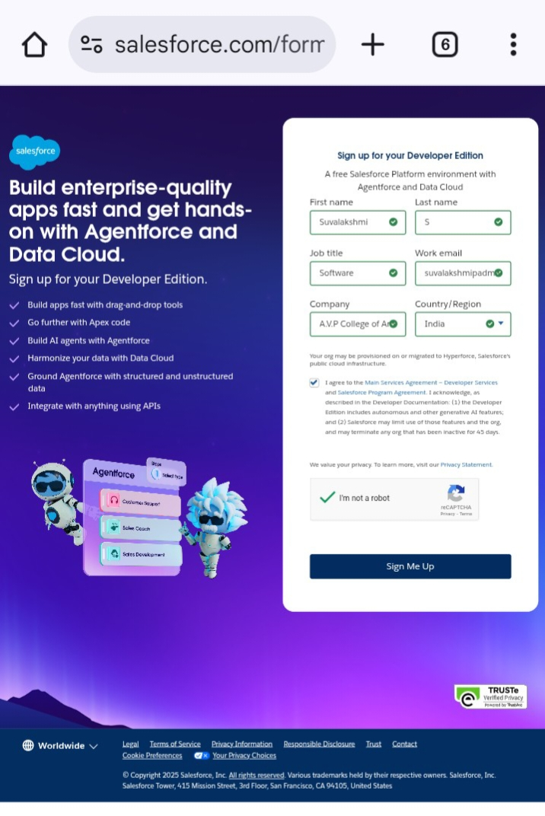

* Created Objects: Jewel Customer, Item, Customer Order, Price and Billing.

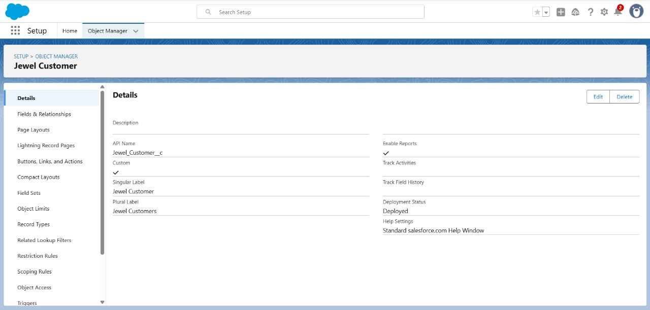

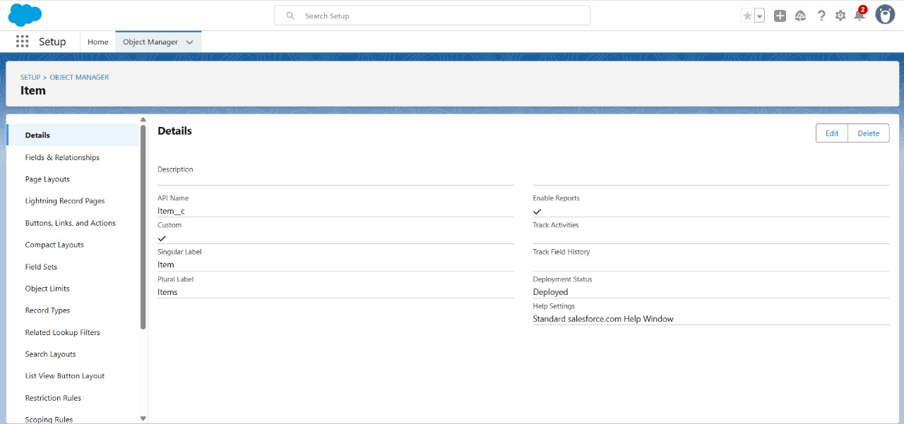

* Created Fields and Relationships

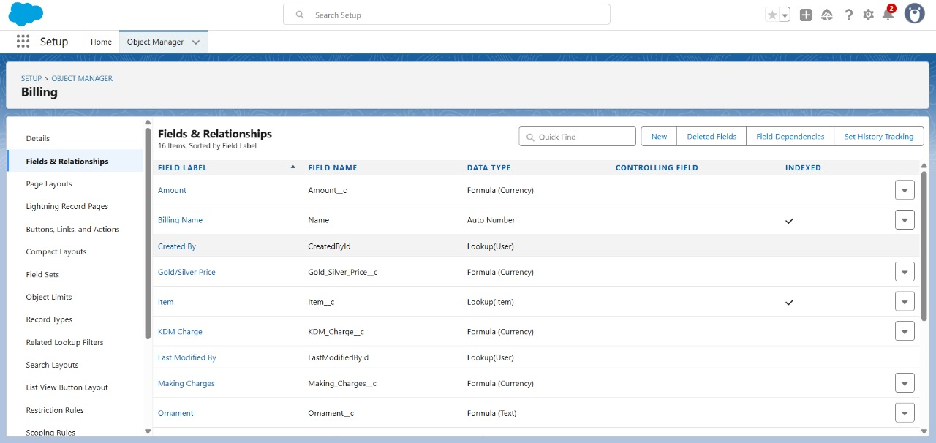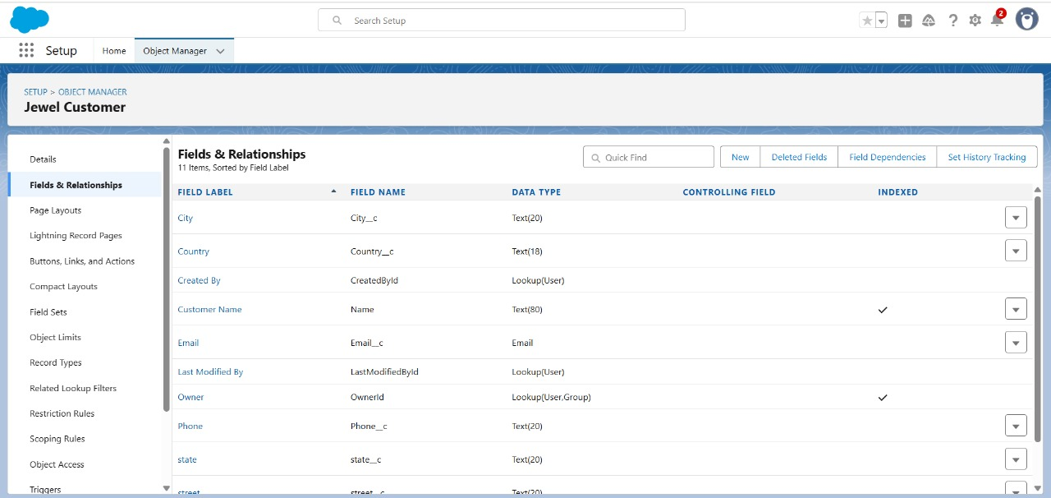

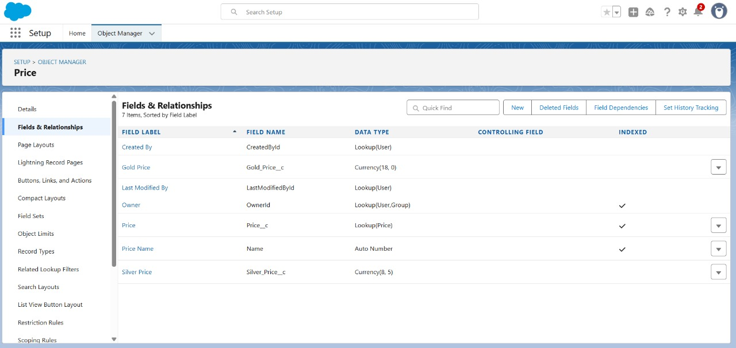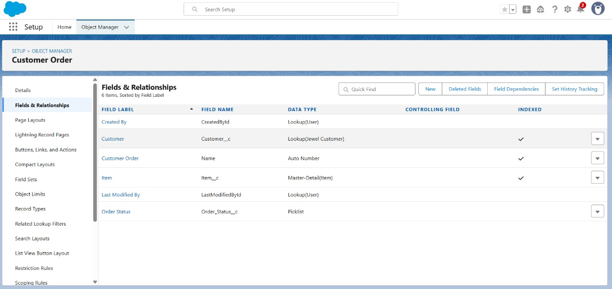

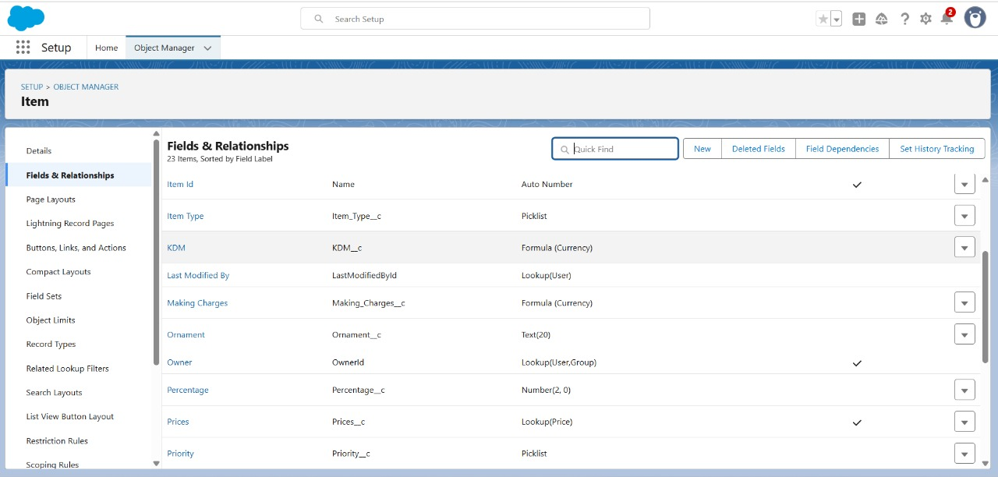

* Developed Lightening App with relevant tabs

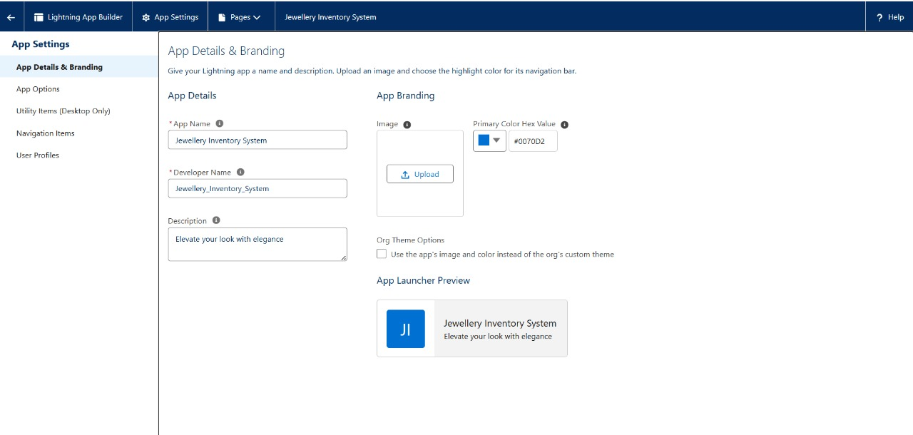

* Custom tabs

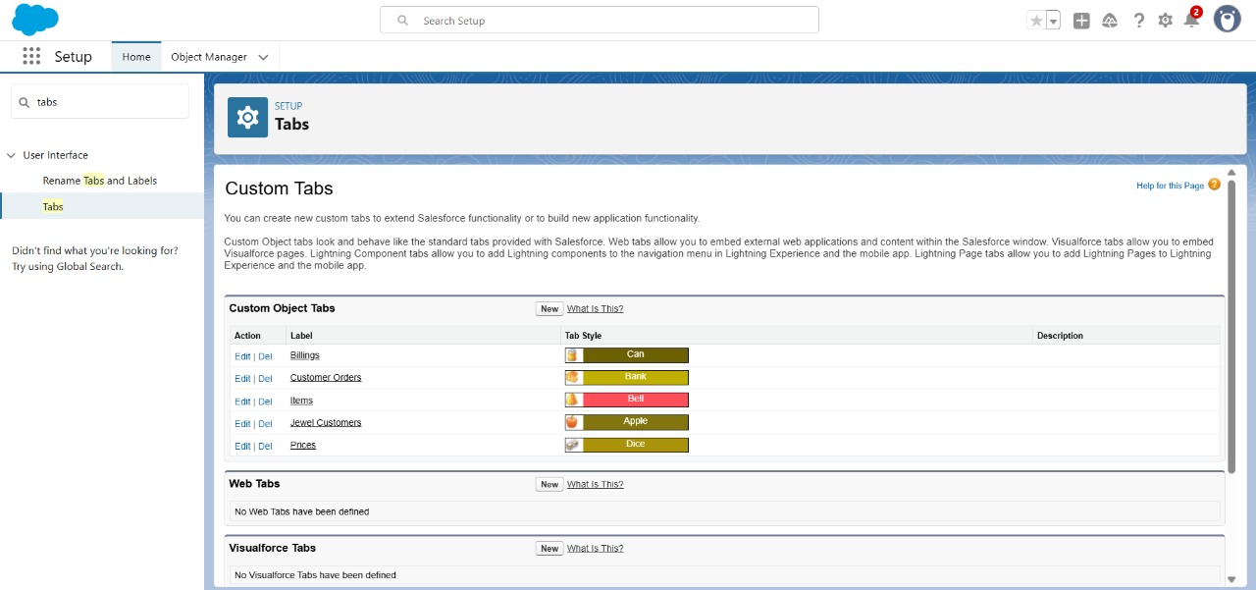

* Validation rules for Jewel Customer and Item object

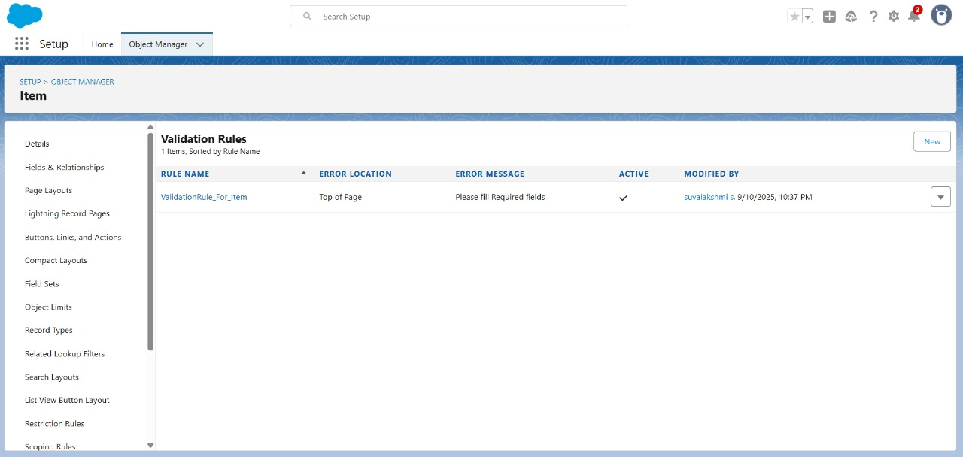

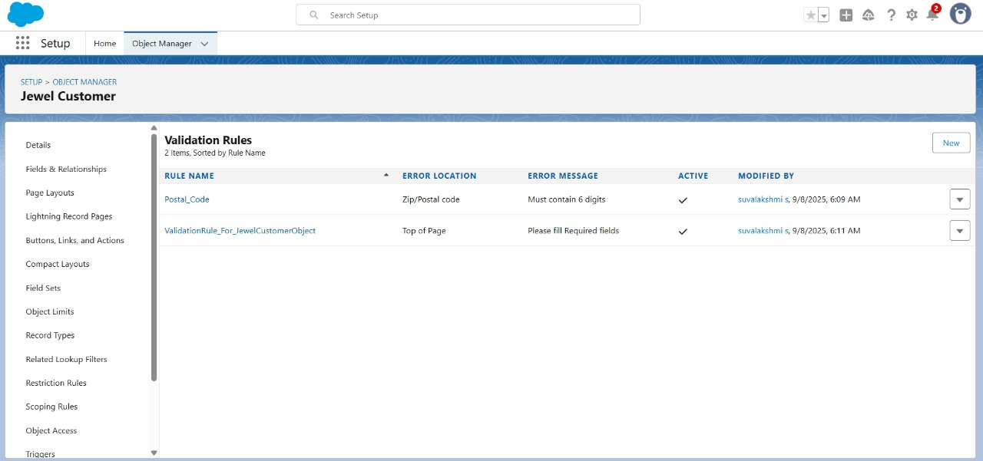

* Created profiles for Gold Smith and Worker

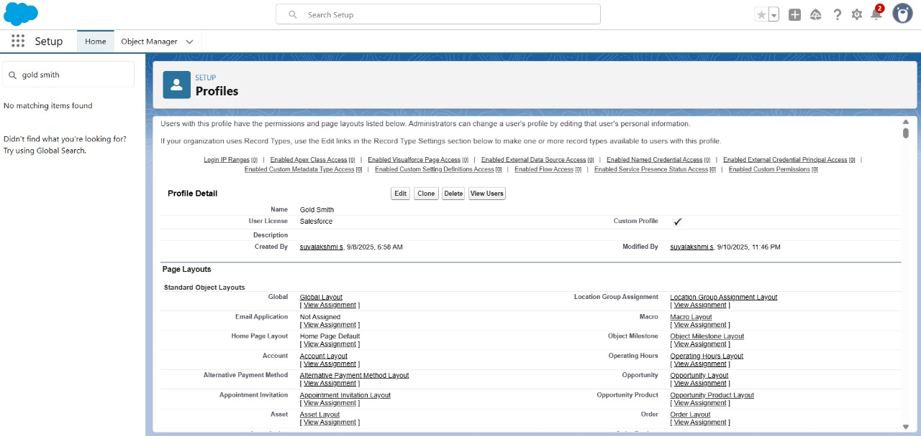

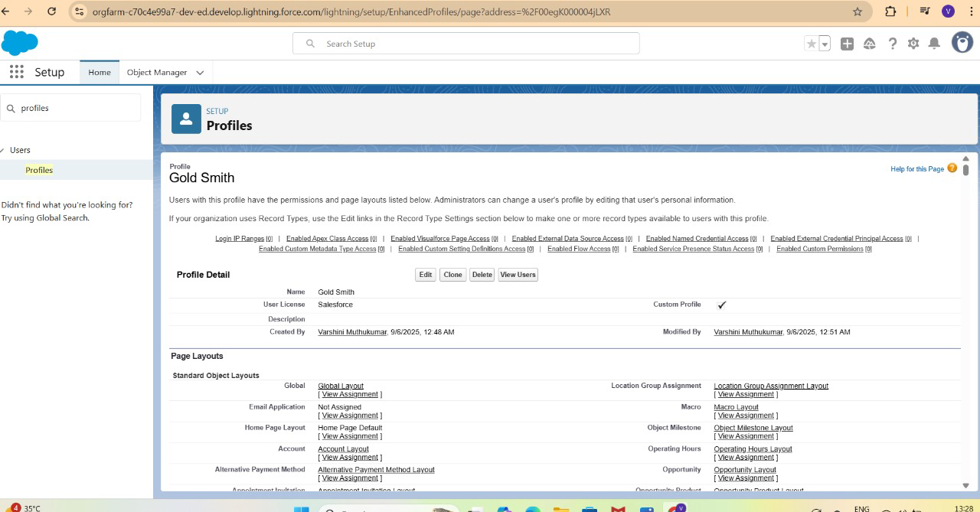

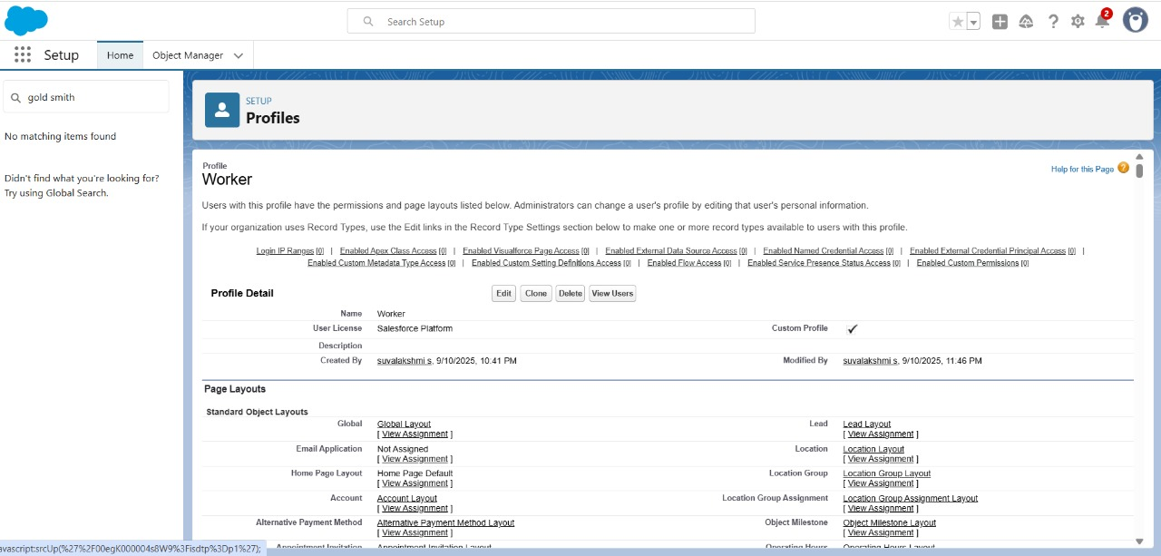

* Created Users

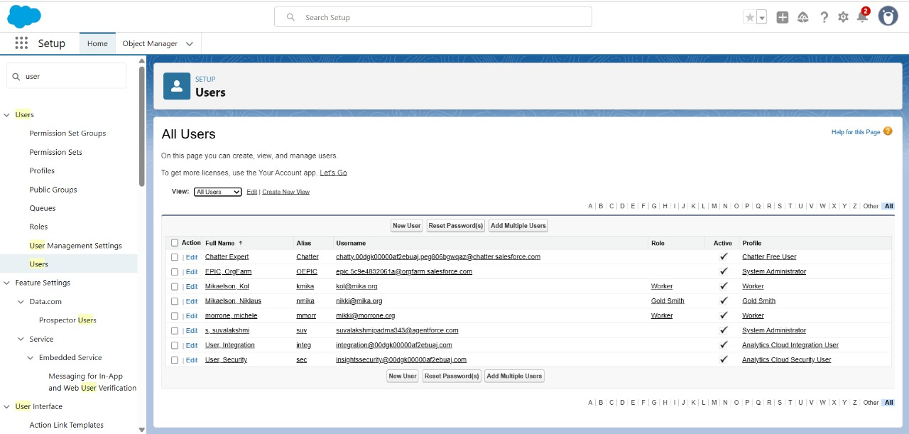

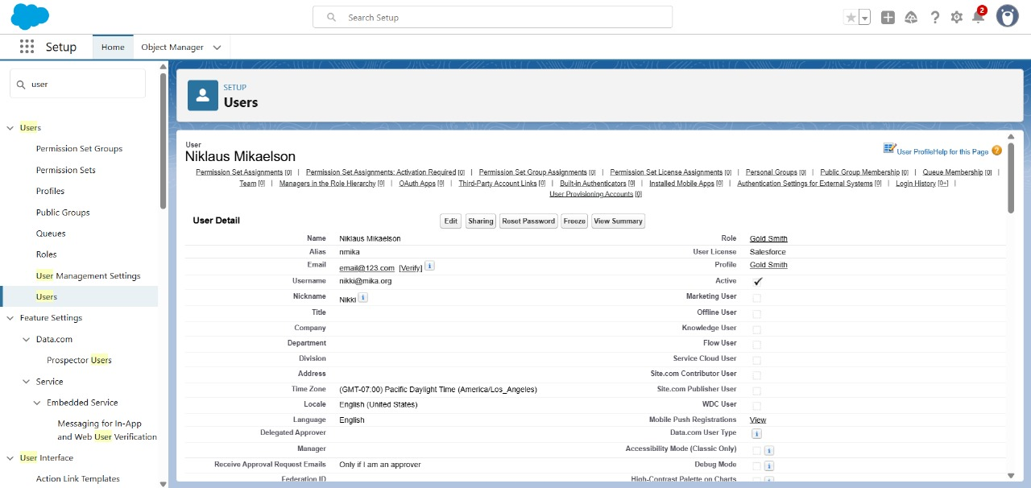

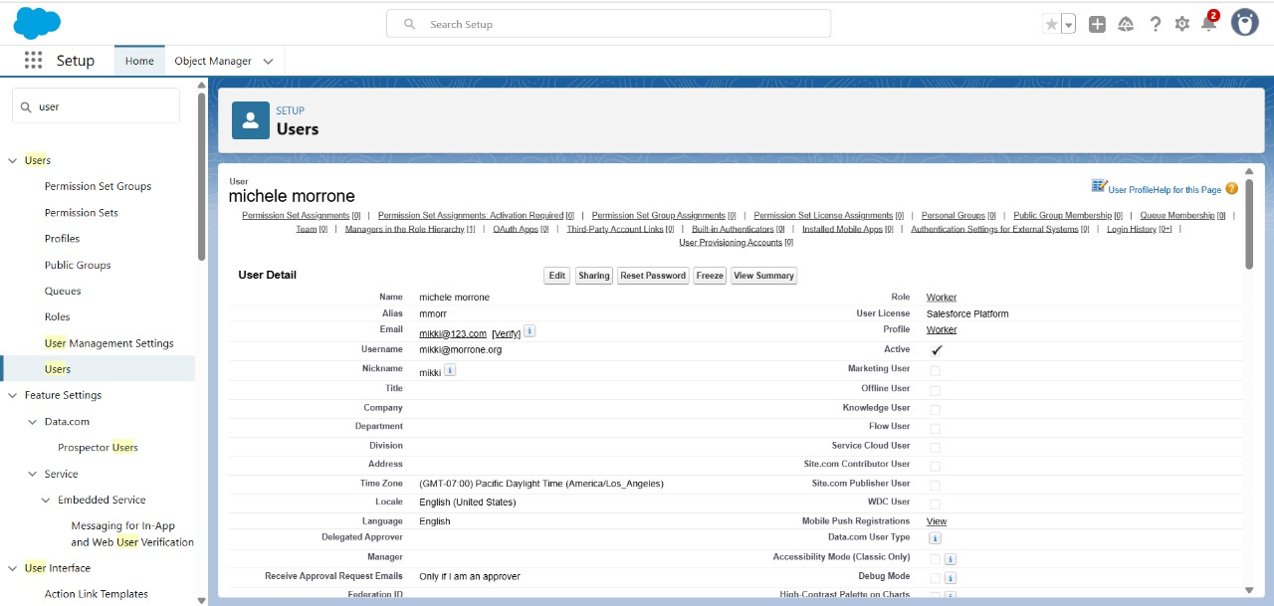

* Roles

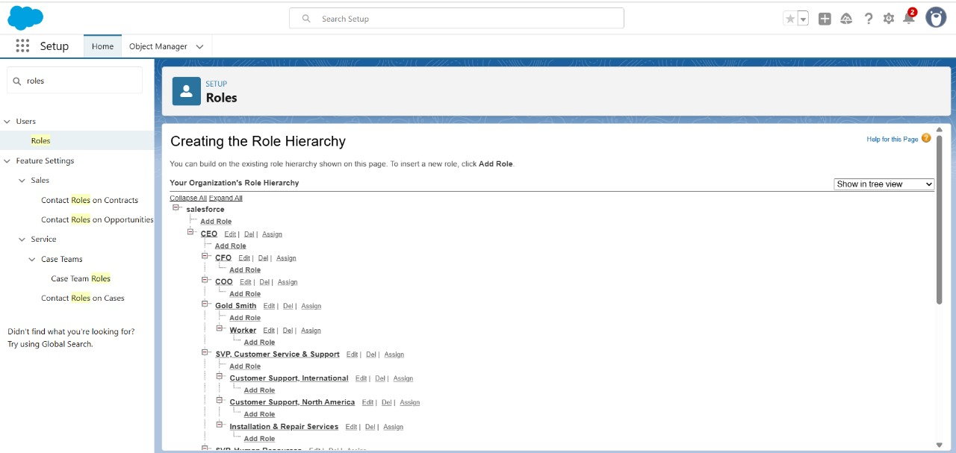

* Created page layouts

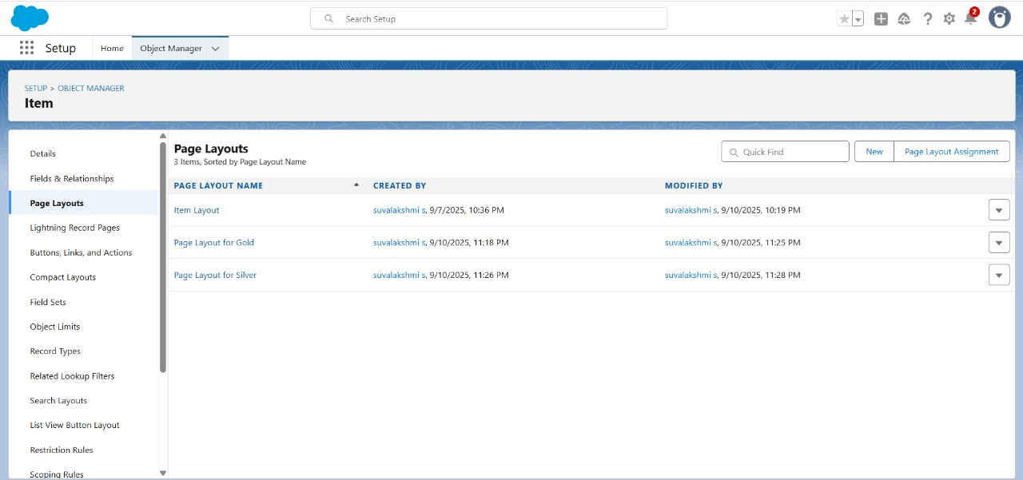

* Created Record Types: Gold and Silver

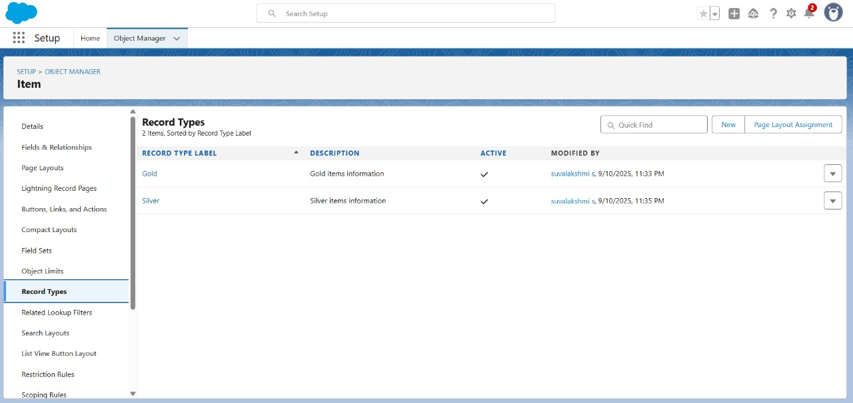

* Permission sets

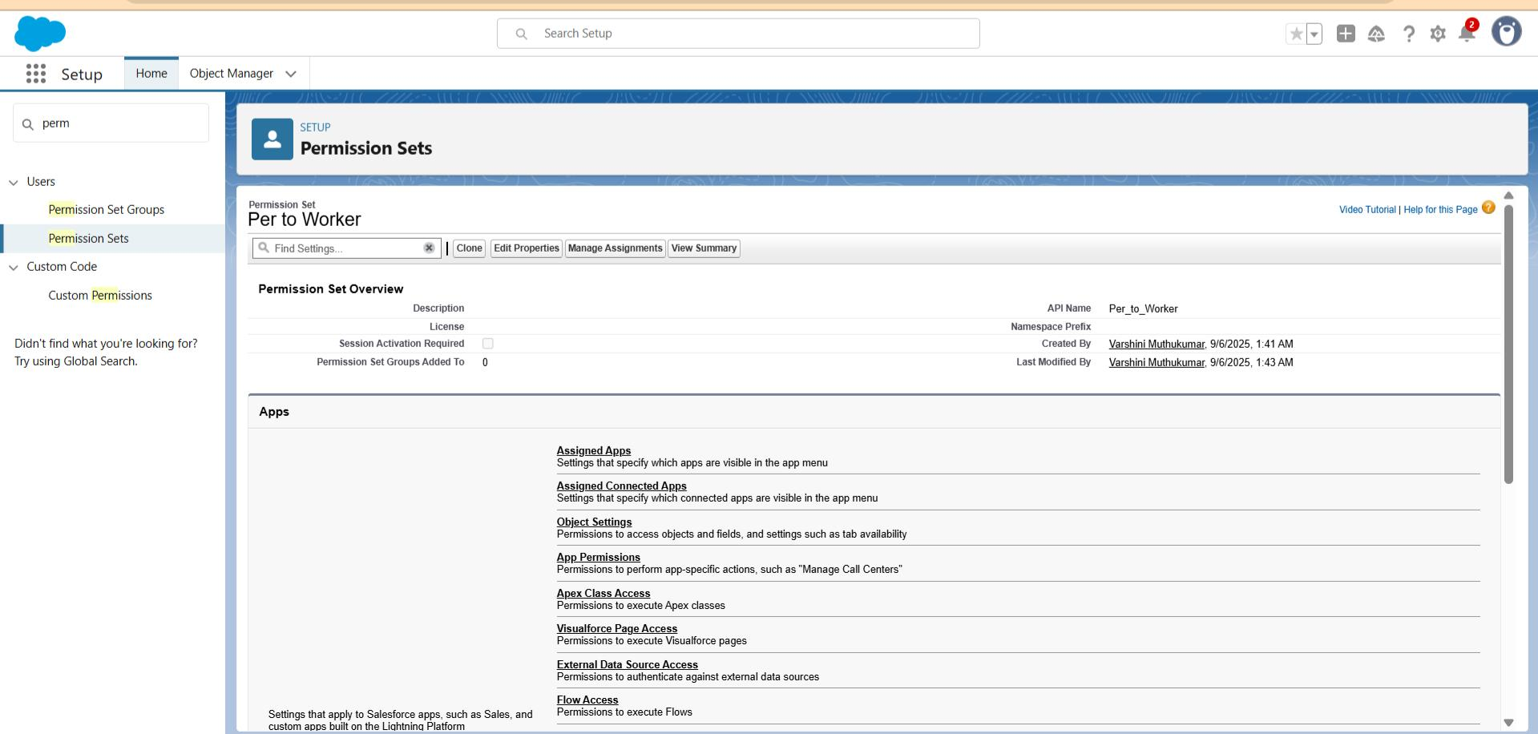

* Created trigger: Update paid amount Trigger

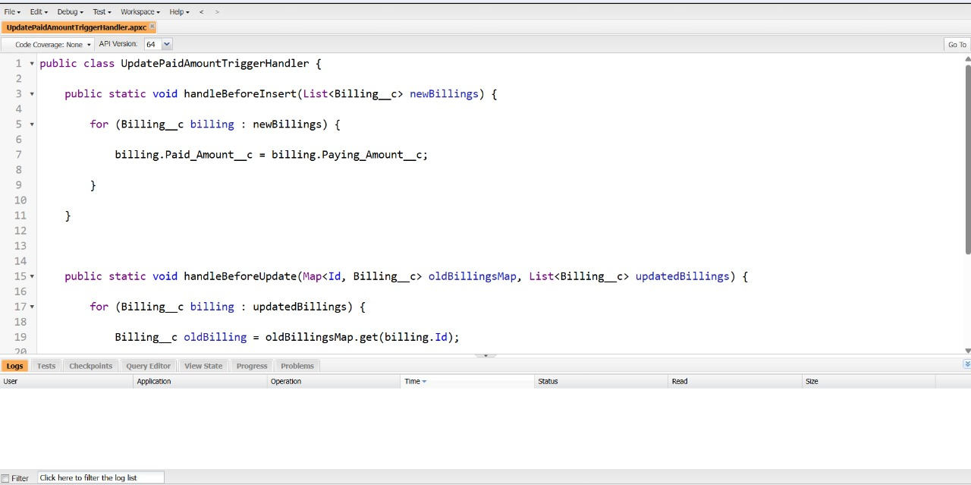

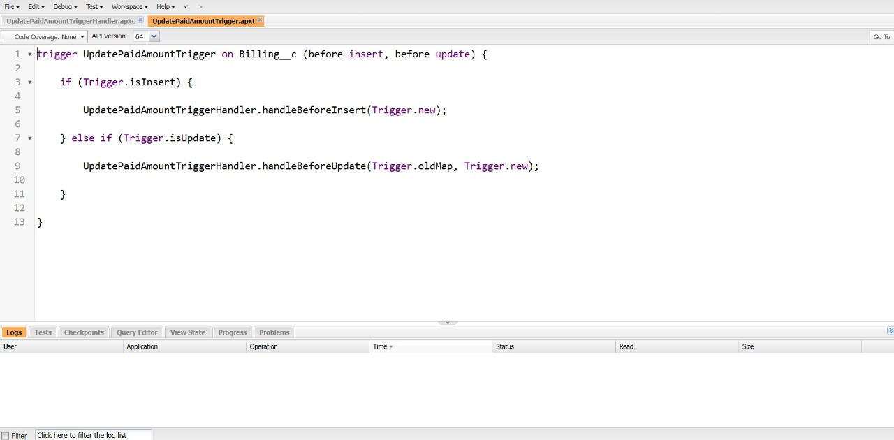

* User Adoption:

1. Create a record
2. View a record
3. 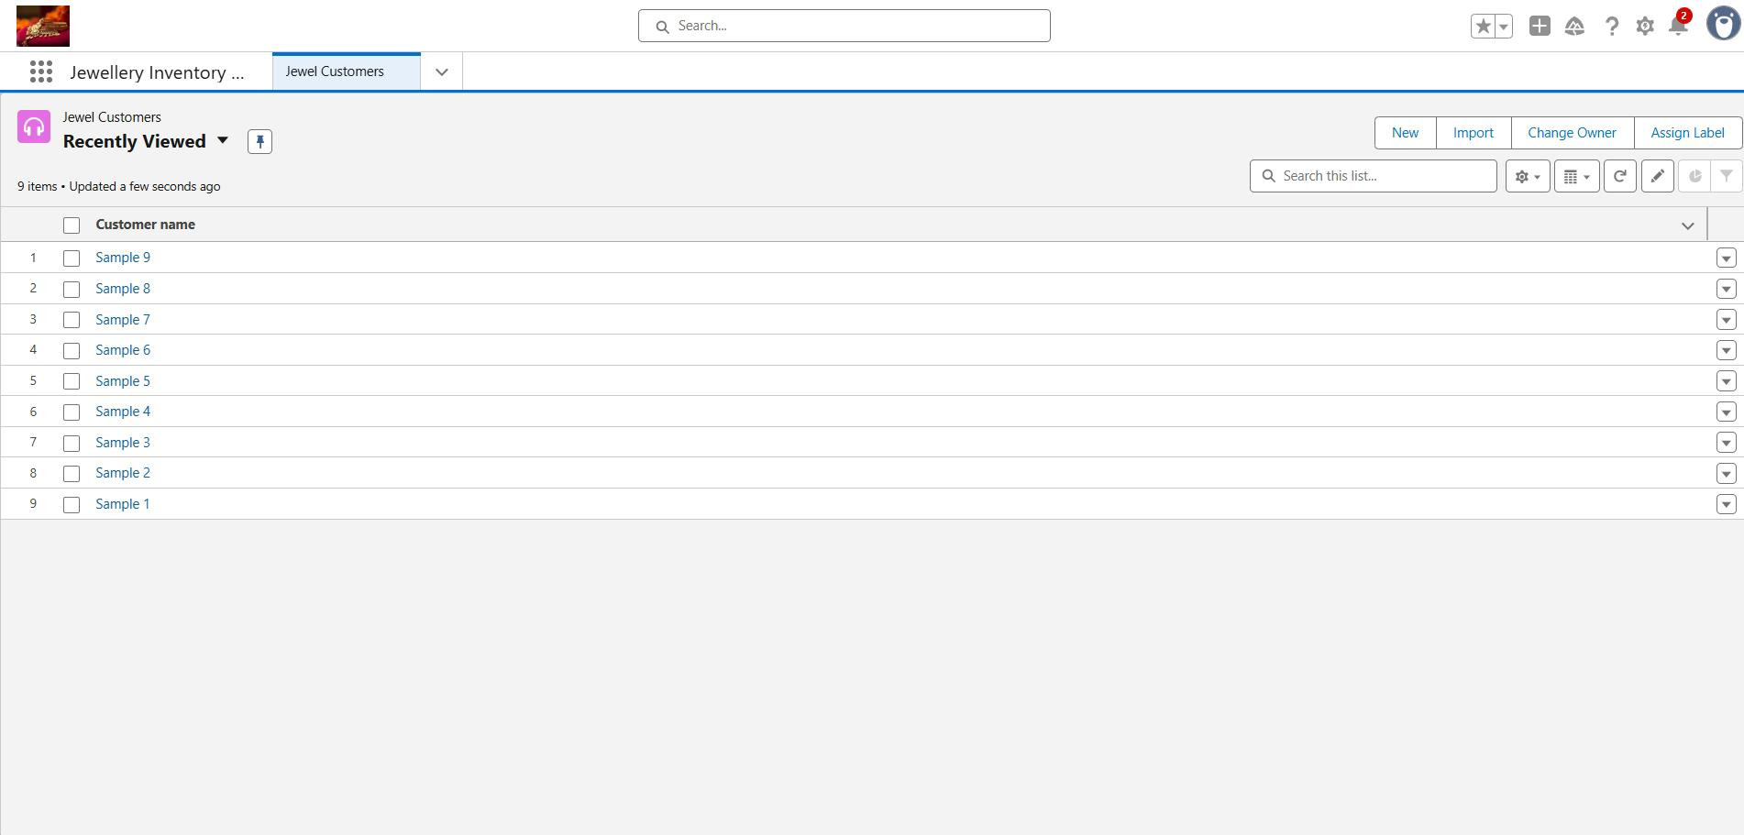Delete a record

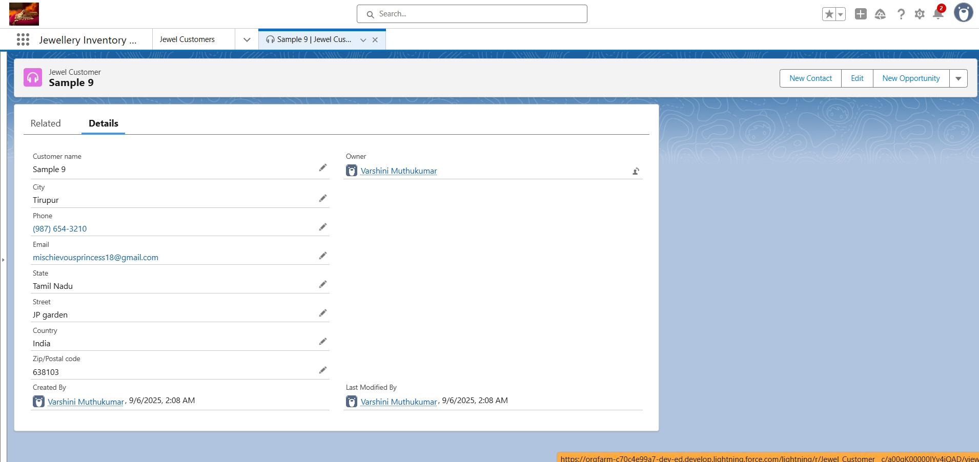

* Created Reports: Items with billings and Billing with items and customer order.

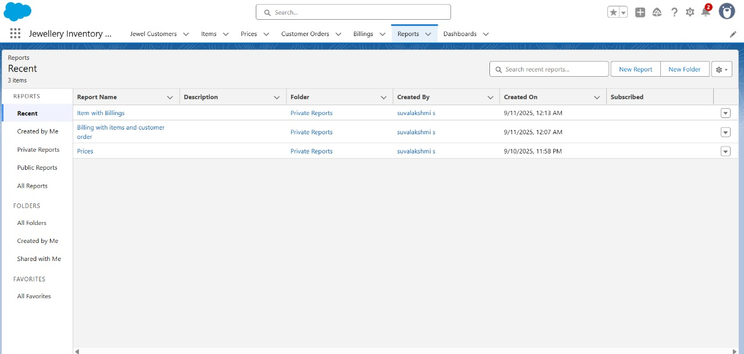

* Dashboards

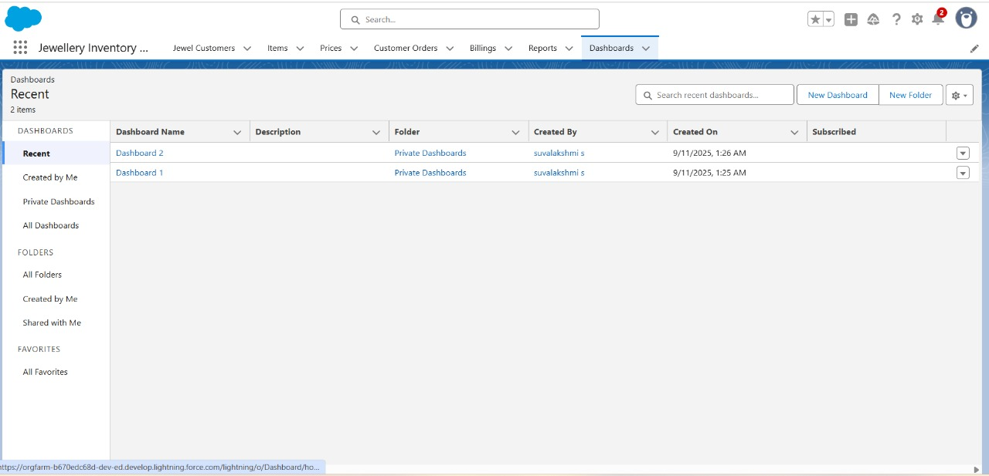

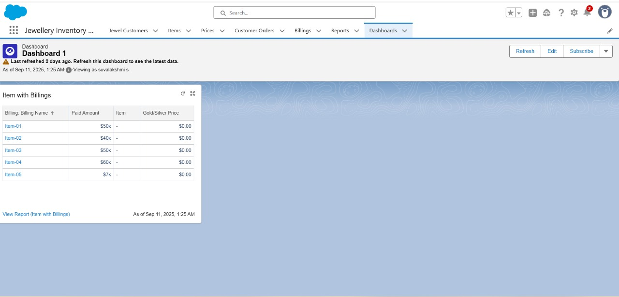

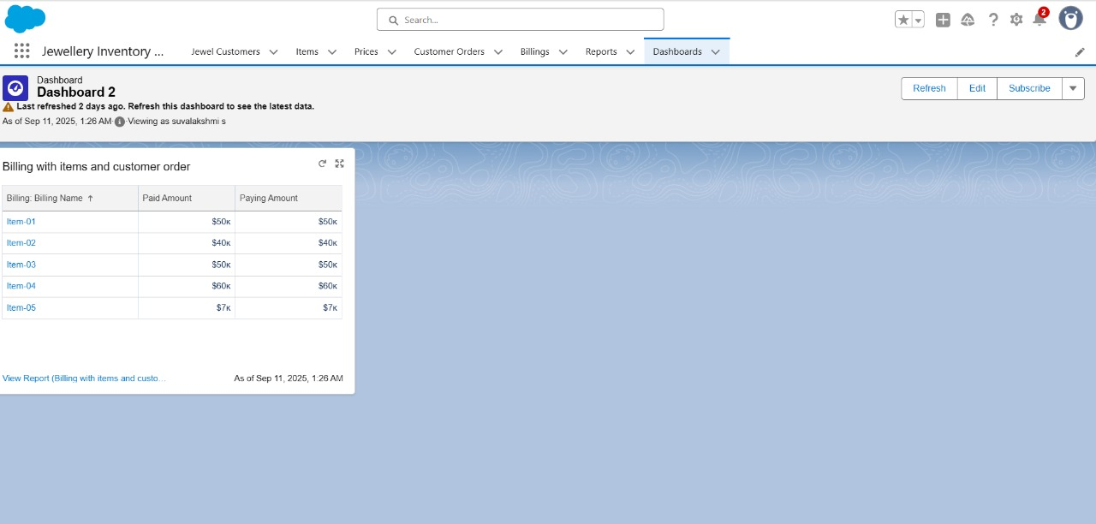

* Created Flow

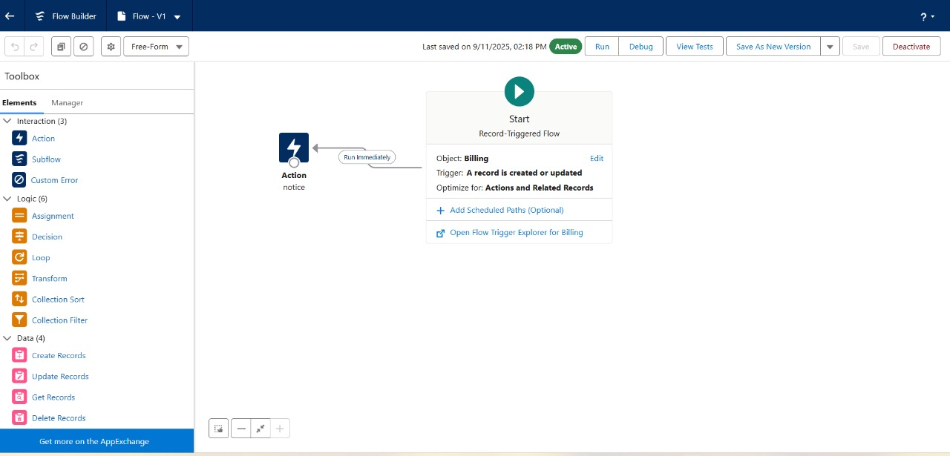

Conclusion

By implementing a CRM system specifically tailored for jewel management, you transform customer-centric operations into a strategic advantage. The CRM consolidates customer profiles enabling personalized outreach for birthdays, anniversaries, and past purchases bolstering customer loyalty and repeat engagement. Automated workflows like follow‑ups and reminders reduce manual effort and ensure sales opportunities are never missed. Real‑time inventory visibility and seamless order tracking facilitate accurate fulfillment and operational efficiency. Finally, advanced analytics and reporting give jewelers clear insights into sales trends, customer behavior, and inventory performance empowering smarter, data-driven decisions that drive growth.

In short: a jewelry-focused CRM isn’t just software it’s a growth engine, enhancing customer satisfaction, streamlining operations, and enabling smarter strategic decisions.